**Graphic Era Hill University, Haldwani**

MCA PROJECT REPORT

FOR

**MIND TREE**

**Using HTML, CSS JS**

Submitted to Graphic Era Hill University, Haldwani for the partial fulfilment of the requirement for the Award of Degree for

MASTER OF COMPUTER APPLICATION



**Submitted by: Under the Guidance of:**

**Tarun Joshi Mr Kamlesh Sir**

**Ajay Singh Bohra Assistant Professor**

**MIND TREE**

A mini project report submitted by

**Tarun Joshi (237112507)**

**Ajay Singh Bora ( 237112531 )**

in partial fulfilment for the award of the degree

of

# MASTERS Of COMPUTER APPLICATION

under the supervision of

# Mr. Kamlesh Sir,

# Miss Neha Sharma

**( Assistant Professor )**



## DEPARTMENT OF COMPUTER SCIENCE AND ENGINEERING

## GRAPHIC ERA HILL UNIVERSITY

**Tularampur, Near Mahalaxmi Temple, opp. Midas Square,**

**Haldwani, Uttarakhand 263139**

# MAY 2025



## BONAFIDE CERTIFICATE

This is to certify that the project report entitled, “**MIND-TREE** ” is a Bonafide record of

Mini Project work done during the even semester of the academic year 2024-25 by

**Tarun Joshi (237112507)**

**Ajay Singh Bora ( 237112531 )**

In partial fulfilment of the requirements for the award of the degree of Master of Computer Application.

Submitted on _________________

#### Project Coordinator Signature of the Guide

# CONTENTS

* Acknowledgment
* Abstract
* Introduction
* Problem Statement and Engineering Approach
* Design
* Code
* Flow Diagram and Output
* Conclusion
* References
* Biblography

## ACKNOWLEDGEMET

We would like to express our heartfelt gratitude to **Mindtree** and the organizers of **Hackofiesta** for providing us the opportunity to participate in this exciting and enriching hackathon. This project, *Sukoon*, marks our first venture into hackathon development, and it has been a transformative learning experience. We extend our thanks to our mentors, peers, and every contributor who supported us throughout this journey. Their insights and encouragement played a vital role in the successful completion of this project.

Tarun Joshi

Ajay Sinngh Bohra

### **ABSTRACT**

**Sukoon** is a stress-relieving web platform developed under the **Healthcare** theme for **Hackofiesta**. It aims to address the growing concern of mental health and stress management among individuals, especially in fast-paced work and academic environments. The website integrates multiple therapeutic solutions such as **audio therapy**, **reading therapy**, **yoga**, **laughing therapy**, and **talking therapy**, combined with resources to consult certified professionals. By offering a holistic set of tools including calming playlists, motivational podcasts, yoga tutorials, and mental health articles, *Sukoon* strives to help users lead a balanced, peaceful, and productive life.

# CHAPTER 1

# INTRODUCTION

In today’s digital age, mental well-being often takes a backseat due to increasing workloads, academic pressure, and personal challenges. *Sukoon* is a web-based initiative designed to support mental health by creating a calming, resource-rich digital space. With a simple and intuitive interface, the platform provides curated content aimed at reducing stress and anxiety. This project was developed as part of our participation in Hack fiesta, and represents our commitment to solving real-world problems using technology.

# CHAPTER 2

# Problem Statement

The modern lifestyle has contributed to a rise in stress-related disorders. Despite the availability of stress-relief resources, there is no unified, accessible platform that offers diverse forms of therapy and mental wellness tools in one place. People often don’t know where to start or whom to consult.

**Engineering Approach**

To solve this problem, we designed *Sukoon* with a **modular and user-friendly architecture**. The engineering approach included:

* **Frontend Development:** HTML, CSS, and JavaScript for clean UI/UX design.
* **Content Integration:** Embedded music, videos, quotes, articles, and external resource links for various therapies.
* **Navigation System:** Easy access to each therapy type (Audio, Yoga, Reading, etc.) through categorized sections.
* **Responsive Design:** Ensured compatibility across devices for broader reach.
* **Open Source Development:** Encouraged community contribution via GitHub to continually enhance the project.

By blending technology with psychology-based therapeutic methods, *Sukoon* offers a unique platform that promotes mental well-being and self-care.

## SOFTWARE ENGINNERING APPROCH

For developing the code, and the whole algorithm, it was preferable to use Matlab. Indeed, in this environment, image displaying, graphical analysis and image processing turn into a simple enough issue concerning the coding, because Matlab has a huge and the fact that Matlab is optimized for matrix-based calculus make any image treatment more easier given that any image can be considered as a matrix.

That's why the whole Code has been developed first under Matlab environment. Only the code of the Image Scanning Method and of the Weighted Averaging Analysis method is provided. Indeed, given that the last one is a kind of combination of the Pixel Counting Method and of the Edge Counting Method: their respective codes may be extracted from the code of the Weighted Averaging Method.

For the movement of de motor of the robot, the program has been written in assembly language since it is most suitable, and we are well aware of the subject. The IC used is 8051 microcontrollers, hence the code was written and tested in Keil C software.

# CHAPTER 3

# Design

The design of *Sukoon* focuses on delivering a **calm, intuitive, and responsive user experience** to ensure accessibility and ease of use for individuals dealing with stress. The platform is structured to guide users smoothly through various therapy options with minimal distractions.

**🧩 User Interface (UI) Design**

* **Minimalistic Layout:** Clean and soothing visual elements with soft colors (e.g., pastel tones) to create a peaceful browsing experience.
* **Easy Navigation:** Clearly defined sections for each therapy—Audio, Reading, Yoga, Laughing, and Consultation—accessible through a well-organized navbar or homepage tiles.
* **Typography:** Readable fonts with good spacing to reduce visual strain and promote relaxed reading.

**🖥️ Responsive Design**

* Built with **responsive web design principles** to ensure optimal performance across devices (desktop, tablet, mobile).
* Flexbox and media queries are used for dynamic resizing and content adaptation.

**⚙️ Technical Stack**

* **Frontend:** HTML, CSS, JavaScript
* **Media Integration:** Embedded YouTube videos, audio files, and article previews
* **Open Source:** Hosted on GitHub with support for external contributions and improvements

**💡 User Experience (UX) Goals**

* **Reduce cognitive overload** through organized content presentation
* **Encourage interaction** by offering relaxing and interactive resources
* **Maintain emotional comfort** using visually pleasing UI components and stress-friendly navigation

**🎨 Color Palette and Visual Identity**

* Colors like **light blue**, **lavender**, and **white** dominate the interface to maintain a calming tone.
* The **Sukoon logo** reinforces the brand identity, conveying peace and relief through its design.

# CHAPTER 4

# Code

<!DOCTYPE html>

<html lang="en">

<head>

  <meta charset="UTF-8" />

  <meta http-equiv="X-UA-Compatible" content="IE=edge" />

  <meta name="viewport" content="width=device-width, initial-scale=1.0" />

  <title>Mind-Tree</title>

  <link rel="icon" href="/images/favicon-enhanced.png">

  <link rel="stylesheet" href="css/style.css" />

  <link rel="manifest" href="manifest.json">

  <link rel="apple-touch-icon" href="/images/favicon-enhanced.png" />

  <meta name="theme-color" content="#000000" />

  <link rel="stylesheet" text="text/CSS"

    href="https://cdnjs.cloudflare.com/ajax/libs/font-awesome/6.1.1/css/all.min.css">

  <link rel="stylesheet" type="text/css"

    href="https://cdnjs.cloudflare.com/ajax/libs/OwlCarousel2/2.3.4/assets/owl.carousel.min.css">

  <link rel="stylesheet" text="text/CSS"

    href="https://cdnjs.cloudflare.com/ajax/libs/font-awesome/6.1.1/css/all.min.css">

  <link href="https://unpkg.com/aos@2.3.1/dist/aos.css" rel="stylesheet">

</head>

<style>

  html {

    scroll-behavior: smooth;

  }

  .hidden {

    visibility: hidden;

  }

  .back-top-wrap {

    position: fixed;

    bottom: 5rem;

    right: 1rem;

    background-color: #80F7D1;

    padding: 1rem 1.2rem;

    border-radius: 50%;

    cursor: pointer;

    transition: .3s ease-in-out;

    z-index: 100;

  }

  .back-top-wrap:hover {

    background-color: #00a2ff;

    color: #80F7D1;

  }

  .back-top-wrap:hover .fas.fa-arrow-up {

    color: white;

  }

  .fas.fa-arrow-up {

    color: #00488F;

    transition: 0.3s ease-in-out;

  }

</style>

<body onload="myFunction()">

  <div class="loading-wrapper">

    <img src="./logo.png" id="loading" />

  </div>

  <!-- Back to top button -->

  <div id="back-top-div" class="back-top-wrap">

    <i class="fas fa-arrow-up"></i>

  </div>

  <header>

    <nav class="nav" id="nav">

      <div>

        <a class="navbar-brand" href="#!"> <img src="logo.png" alt="Logo" class="logo" /></a>

      </div>

      <div class="nav-links" id="navLinks">

        <ul class="links" id="navmenu">

          <li><a href="#">HOME</a></li>

          <li><a href="#about">ABOUT</a></li>

          <li><a href="#services">SERVICES </a></li>

          <li><a href="html/contact.html">CONTACT US </a></li>

        </ul>

      </div>

      <button class="login-button"><a href="html/login.html">SignUp / Login</a></button>

      <div class="hamburger" id="ham">

        <i class="cancel fa-solid fa-xmark"></i>

        <svg class="burger" stroke="currentColor" fill="currentColor" stroke-width="0" viewBox="0 0 1024 1024" height="1em" width="1em"

          xmlns="http://www.w3.org/2000/svg">

          <path

            d="M904 160H120c-4.4 0-8 3.6-8 8v64c0 4.4 3.6 8 8 8h784c4.4 0 8-3.6 8-8v-64c0-4.4-3.6-8-8-8zm0 624H120c-4.4 0-8 3.6-8 8v64c0 4.4 3.6 8 8 8h784c4.4 0 8-3.6 8-8v-64c0-4.4-3.6-8-8-8zm0-312H120c-4.4 0-8 3.6-8 8v64c0 4.4 3.6 8 8 8h784c4.4 0 8-3.6 8-8v-64c0-4.4-3.6-8-8-8z">

          </path>

        </svg>

      </div>

    </nav>

    <div class="menu" id="menu">

      <ul class="menu-link">

        <li><a href="#">HOME</a></li>

        <li><a href="#about">ABOUT</a></li>

        <li><a href="#services">SERVICES </a></li>

        <li><a href="html/contact.html">CONTACT US </a></li>

      </ul>

    </div>

    <div class="content">

      <h1>Your Journey Begins at Mind-Tree to GEHU Haldwani!</h1>

      <div class="container">

        <h3><span class="auto-type" style="font-size: 40px;font-family:'Lucida Sans', 'Lucida Sans Regular', 'Lucida Grande', 'Lucida Sans Unicode', Geneva, Verdana, sans-serif;"></a></span></h3>

      </div>

      <script src="https://cdn.jsdelivr.net/npm/typed.js@2.0.12"></script>

      <script>

        var typed = new Typed(".auto-type", {

          strings: ["The one-step solution to get relief from your stress. Live a stress-free life!"],

          typeSpeed: 50,

          backspeed: 50,

          loop: true

        })

      </script>

      <a href="#services" class="rainbow-button" alt="Explore"></a>

    </div>

  </header>

  <!-- About Section -->

  <section id="about" class="about">

    <h1 data-aos="flip-right">About Us</h1>

    <div class="max-width">

      <div data-aos="zoom-in" class="photo"><img src="./images/about.jpg" alt="" height="300px" width="330px"></div>

      <div class="about-content">

        <p data-aos="fade-left" class="text-1"> We are a team of open source contributors who have created this website

          Mind-Tree GEHU Hld. with the aim to provide a <span>one step solution</span> to get relief from stress. </p>

        <p data-aos="fade-left" class="text-3">We hope that everyone can live a <span>stress free life </span>with the

          help of<span> Mind-Tree.</span></p>

      </div>

    </div>

    <h3><span style="color: rgb(91, 134, 150);">MEET OUR MEMBERS</span></h3>

    <div class="box">

      <!--         <div class="card">

          <img src="./images/shayan.jpeg" alt="shayan" loading="lazy">

          <h5>Shayan Pal</h5>

          <div class="pra">

            <p>Member</p>

            <a href="https://bio.link/shayanpal"><button>Let's Connect</button></a>

          </div>

        </div> -->

      <div data-aos="fade-up" ddata-aos-duration="800" class="card">

        <img src="./images/OWN.jpg" alt="Tarun Joshi" loading="lazy">

        <h5>Tarun Joshi</h5>

        <div class="pra">

          <p>Member</p>

          <a href="https://www.linkedin.com/in/tarunjoshi0/"><button>Let's Connect</button></a>

        </div>

      </div>

      <div data-aos="fade-up" data-aos-duration="800" class="card">

        <img src="./images/Ajay.jpg" alt="" loading="lazy">

        <h5>Ajay Singh Bohra</h5>

        <div class="pra">

          <p>Member</p>

          <a href="https://www.linkedin.com/in/ajaysinghbohra "><button>Let's Connect</button></a>

        </div>

      </div>

      <div data-aos="fade-up" data-aos-duration="800" class="card">

        <img src="./images/.jpg" alt="chaitri" loading="lazy">

        <h5>Kamlesh Paladiya</h5>

        <div class="pra">

          <p>Head of The Team</p>

          <a href="https://bio.link/chaitri"><button class="he">Let's Connect</button></a>

        </div>

      </div>

      <div data-aos="fade-up" data-aos-duration="800" class="card">

        <img src="./images/Neha.jpg" alt="sasanka" loading="lazy">

        <h5>Neha Sharma</h5>

        <div class="pra">

          <p>Member</p>

          <a href="https://bio.link/sasankakundu"><button>Let's Connect</button></a>

        </div>

      </div>

    </div>

  </section>

  <!-- SERVICES SECTION -->

  <section id="services">

    <h1>Our Services</h1>

    <div data-aos="zoom-in" data-aos-duration="800" class="container">

      <div class="responsive audio">

        <div class="round-image">

          <img src="./images/audio.png" alt="audio" loading="lazy" />

        </div>

        <div class="description">

          <h2>Audio Therapy</h2>

          <p>

            Listening to music & other audio files often enlightens our mood.

          </p>

          <a href="html/audioTherapy.html">

            Let's Explore

          </a>

        </div>

      </div>

      <div data-aos="zoom-in" data-aos-duration="800" class="responsive reading">

        <div class="round-image">

          <img src="./images/reading.png" alt="read" loading="lazy" />

        </div>

        <div class="description">

          <h2>Reading Therapy</h2>

          <p>

            Motivational quotes and books can help us to divert and change our mood.

          </p>

          <a href="html/readingTherapy.html">

            Let's Explore

          </a>

        </div>

      </div>

      <div data-aos="zoom-in" data-aos-duration="800" class="responsive yoga">

        <div class="round-image">

          <img src="./images/yoga.png" alt="yoga" loading="lazy" />

        </div>

        <div class="description">

          <h2>Yoga Therapy</h2>

          <p>

            Yoga and exercise plays a very important role in our lives.

          </p>

          <a href="html/yogatherapy.html">

            Let's Explore

          </a>

        </div>

      </div>

      <div data-aos="zoom-in" data-aos-duration="800" class="responsive laugh">

        <div class="round-image">

          <img src="./images/laughing.png" alt="laughing" />

        </div>

        <div class="description">

          <h2>Laughing Therapy</h2>

          <p>

            Laughing is the only medicine which refreshes our mind.

          </p>

          <a href="html/laughTherapy.html">

            Let's Explore

          </a>

        </div>

      </div>

      <div data-aos="zoom-in" data-aos-duration="800" class="responsive talk">

        <div class="round-image">

          <img src="./images/talking.png" loading="lazy" alt="talking" />

        </div>

        <div class="description">

          <h2>Talking Therapy</h2>

          <p>

            A quick short conversation can often bring smile to our face.

          </p>

          <a href="html/talkingTherapy.html">

            Let's Explore

          </a>

        </div>

      </div>

      <div data-aos="zoom-in" data-aos-duration="800" class="responsive doctor">

        <div class="round-image">

          <img src="./images/doctor.png" alt="doctor" loading="lazy" />

        </div>

        <div class="description">

          <h2>Consult A Doctor</h2>

          <p>

            If you're facing too many problems, you should consult a doctor.

          </p>

          <a href="https://www.practo.com/counselling-psychology" target="_blank">

            Let's Explore

          </a>

        </div>

      </div>

      <div class="responsive child">

        <div class="round-image">

          <img src="./images/child.jpg" alt="child" loading="lazy" />

        </div>

        <div class="description">

          <h2>Child Therapy</h2>

          <p>

            Children make us forget about worries with their innocence.

          </p>

          <a href="./html/childTherapy.html">

            Let's Explore

          </a>

        </div>

      </div>

      <div class="responsive spiritual">

        <div class="round-image">

          <img src="./images/spiritualtherapy.jpg" alt="spiritual" loading="lazy" />

        </div>

        <div class="description">

          <h2>Spiritual Therapy</h2>

          <p>

            Helps you to become more mindful in your thinking.

          </p>

          <a href="./html/spirituality.html" target="_blank">

            Let's Explore

          </a>

        </div>

      </div>

      <div class="responsive special">

        <div class="round-image">

          <img src="./images/specialtherapy.jpg" alt="special" loading="lazy" />

        </div>

        <div class="description">

          <h2>Special Therapy</h2>

          <p>

            If you need special attention and help from us.

          </p>

          <a href="./html/specialTherapy.html" target="_blank">

            Let's Explore

          </a>

        </div>

      </div>

    </div>

  </section>

  <!-- Testimonials Section -->

  <!-- Testimonials Section -->

  <section id="testimonial" class="section-100">

    <div class="testimonials_heading">

      <h1>Testimonials</h1>

    </div>

    <div class="testimonial-view">

      <div class="owl-carousel">

        <div class="testimonial-box">

          <figure class="testimonal-Card">

            <blockquote> I've explored all therapy pages, but my fav one was audio therapy. It have different calming &

              mood soothing sounds, there are also many podcasts as well. Mind-Tree website really helped me to get relief

              from my stress.

              <div class="arrow"></div>

            </blockquote>

            <img src="./images/Mohit.jpg" alt="sample3" />

            <div class="author">

              <h5>Mohit Namdev</h5>

            </div>

        </div>

        <div class="testimonial-box">

          <!-- <i class="fa fa-quote-left quote-icon"></i> -->

          <figure class="testimonal-Card hover">

            <blockquote> I'm really loving the laughing therapy and reading therapy pages. The standup videos present in

              the laughing therapy page cheer me up, and the quotes present in the reading therapy page are really

              motivating. <div class="arrow"></div>

            </blockquote>

            <img src="./images/vanshita.jpg" alt="sample47" />

            <div class="author">

              <h5>Vanshita Mathur</h5>

            </div>

          </figure>

        </div>

        <div class="testimonial-box">

          <!-- <i class="fa fa-quote-left quote-icon"></i> -->

          <figure class="testimonal-Card">

            <blockquote>As a student, I love using this website, Mind-Tree is like having a personal therapist. Features

              and UI of the website is amazing and it really helped me to manage a lot of my anxiety and stress. I also

              feel much supported by the lines of quotes than a human.

              <div class="arrow"></div>

            </blockquote>

            <img src="./images/Shravani Kaware.jpg" alt="sample17" />

            <div class="author">

              <h5>Shravani Kaware</h5>

            </div>

          </figure>

        </div>

        <div class="testimonial-box">

          <!-- <i class="fa fa-quote-left quote-icon"></i> -->

          <figure class="testimonal-Card">

            <blockquote>I'm really liking Audio, Reading and Yoga therapy because it's helpful for me during studying

              time and last but not least Laughing therapy is also my favorite because whenever I am feeling lonely at

              that time I am watching my childhoods cartoon show like Mr. bean and also watching memes.

              <div class="arrow"></div>

            </blockquote>

            <img src="./images/Kelvin Parmar.jpg" alt="sample17" />

            <div class="author">

              <h5>Kelvin Parmar</h5>

            </div>

          </figure>

        </div>

      </div>

    </div>

    </div>

  </section>

  <!-- Faq section -->

  <section class="faq">

    <div class="faq_heading">

      <h1>Frequently Asked Questions</h1>

    </div>

    <div class="accordion">

      <div class="accordion__item">

        <button class="accordion__btn">

          <span class="accordion__caption"><i class="far fa-lightbulb"></i>Who are we and what do we do?</span>

          <span class="accordion__icon"><i class="fa fa-plus"></i></span>

        </button>

        <div class="accordion__content">

          <p>We are a team of open source contributors who have created this website "Mind-Tree"

            with the aim

            to provide a one step solution to get relief from stress. We hope that everyone can live a

            stress free life with the help of Mind-Tree.</p>

        </div>

      </div>

      <div class="accordion__item">

        <button class="accordion__btn">

          <span class="accordion__caption"><i class="far fa-lightbulb"></i>What are the services we offer?</span>

          <span class="accordion__icon"><i class="fa fa-plus"></i></span>

        </button>

        <div class="accordion__content">

          <p>We offer multiple services like:

            <br>

            1. Audio Therapy

            <br>

            2. Reading Therapy

            <br>

            3. Yoga Therapy

            <br>

            4. Laughing Therapy

            <br>

            5. Talking Therapy

            <br>

            6. Doctor Consultation

            <br>

            7. Child Therapy

            <br>

            8. Spiritual Therapy

          </p>

        </div>

      </div>

      <div class="accordion__item">

        <button class="accordion__btn">

          <span class="accordion__caption"><i class="far fa-lightbulb"></i>How can you Contact Us?</span>

          <span class="accordion__icon"><i class="fa fa-plus"></i></span>

        </button>

        <div class="accordion__content">

          <p> You can contact us via <a class="email" href="mailto:jtarun345@gmail.com">jtarun345@gmail.com</a>

          </p>

        </div>

      </div>

      <div class="accordion__item">

        <button class="accordion__btn">

          <span class="accordion__caption"><i class="far fa-lightbulb"></i>What is Reading Therapy?</span>

          <span class="accordion__icon"><i class="fa fa-plus"></i></span>

        </button>

        <div class="accordion__content">

          <p>Reading therapy is a creative art therapy that uses literature to support good

            mental health and is a versatile and cost-effective treatment. It includes storytelling or the reading of

            specific texts.</p>

        </div>

      </div>

      <div class="accordion__item">

        <button class="accordion__btn">

          <span class="accordion__caption"><i class="far fa-lightbulb"></i>What is Audio Therapy?</span>

          <span class="accordion__icon"><i class="fa fa-plus"></i></span>

        </button>

        <div class="accordion__content">

          <p>Audio Therapy includes auditory and vibratory inputs which are used to influence a person's psychological

            state, includes sound healing, vibroacoustic sound therapy, music, and music therapy.</p>

        </div>

      </div>

      <div class="accordion__item">

        <button class="accordion__btn">

          <span class="accordion__caption"><i class="far fa-lightbulb"></i>What is Yoga Therapy?</span>

          <span class="accordion__icon"><i class="fa fa-plus"></i></span>

        </button>

        <div class="accordion__content">

          <p>Yoga therapy uses yoga postures, breathing exercises, meditation, and guided imagery to improve mental and

            physical health.</p>

        </div>

      </div>

      <div class="accordion__item">

        <button class="accordion__btn">

          <span class="accordion__caption"><i class="far fa-lightbulb"></i>What is Laughing Therapy?</span>

          <span class="accordion__icon"><i class="fa fa-plus"></i></span>

        </button>

        <div class="accordion__content">

          <p>Laughing therapy uses humor to help relieve pain and stress and improve a person's sense of well-being

            through jokes and playful exercises that encourage hearty, continuous, and lively laughter.</p>

        </div>

      </div>

      <div class="accordion__item">

        <button class="accordion__btn">

          <span class="accordion__caption"><i class="far fa-lightbulb"></i>What is Talking Therapy?</span>

          <span class="accordion__icon"><i class="fa fa-plus"></i></span>

        </button>

        <div class="accordion__content">

          <p>Talking therapy involves talking to someone to help deal with negative feelings or other mental health

            problems. It helps shy individuals open up their problems to others so that they can help them overcome

            them.</p>

        </div>

      </div>

      <div class="accordion__item">

        <button class="accordion__btn">

          <span class="accordion__caption"><i class="far fa-lightbulb"></i>What is Child Therapy?</span>

          <span class="accordion__icon"><i class="fa fa-plus"></i></span>

        </button>

        <div class="accordion__content">

          <p>Child therapy includes the watching of cute videos and images of children, as children make us

            forget about our problems with their innocence and cuteness.</p>

        </div>

      </div>

      <div class="accordion__item">

        <button class="accordion__btn">

          <span class="accordion__caption"><i class="far fa-lightbulb"></i>What is Spritual Therapy?</span>

          <span class="accordion__icon"><i class="fa fa-plus"></i></span>

        </button>

        <div class="accordion__content">

          <p>Spiritual therapy is a form of counseling that attempts to treat a person's soul as well as mind and body

            by accessing individual belief systems and using

            that faith in a higher power to explore areas of conflict in life.</p>

        </div>

      </div>

    </div>

    </div>

  </section>

  <!-- footer start -->

  <footer>

    <div class="footer-container">

      <!--logo and info column-->

      <div class="col">

        <!--logo insert-->

        <img src="logo.png" alt="logo" class="footlogo" />

        <div class="footercontent">

          <h2 class="footerheading">Mind-Tree</h2>

          <p class="footerpara">go stress free</p>

        </div>

      </div>

      <!--ADDRESS COLUMN-->

      <div class="footer-side-col">

        <div class="col">

          <h3>

            ADDRESS

            <div class="underline"><span></span></div>

          </h3>

          <p>West Bengal, India</p>

          <p class="email-id"><a href="mailto:jtarun345@gmail.com">jtarun345@gmail.com</a></p>

        </div>

        <!--HOME COLUMN-->

        <div class="col">

          <h3>HOME</h3>

          <ul>

            <li><a href="#about">About Us</a></li>

            <li>

              <a href="https://github.com/Susmita-Dey/Sukoon/blob/main/CODE_OF_CONDUCT.md">Code Of Conduct</a>

            </li>

            <li>

              <a href="https://github.com/Susmita-Dey/Sukoon">Contribute</a>

            </li>

            <li>

              <a href="https://www.buymeacoffee.com/susmitadey">Donate</a>

            </li>

          </ul>

        </div>

        <!--OUR SERVICES COLUMN-->

        <div class="col">

          <h3>

            SERVICES

            <div class="underline"><span></span></div>

          </h3>

          <ul>

            <li>

              <a href="https://sukoon-stress-free.netlify.app/html/audiotherapy">Audio Therapy</a>

            </li>

            <li>

              <a href="https://sukoon-stress-free.netlify.app/html/readingtherapy">Reading Therapy</a>

            </li>

            <li>

              <a href="https://sukoon-stress-free.netlify.app/html/yogatherapy.html">Yoga Therapy</a>

            </li>

            <li>

              <a href="https://sukoon-stress-free.netlify.app/html/laughTherapy.html">Laughing Therapy</a>

            </li>

            <li>

              <a href="https://sukoon-stress-free.netlify.app/html/talkingtherapy">Talking Therapy</a>

            </li>

            <li>

              <a href="https://www.practo.com/counselling-psychology">Consult a Doctor</a>

            </li>

            <li>

              <a href="https://sukoon-stress-free.netlify.app/html/childTherapy">Child Therapy</a>

            </li>

            <li>

              <a href="https://sukoon-stress-free.netlify.app/html/spirituality">Spiritual Therapy</a>

            </li>

            <li>

              <a href="https://sukoon-stress-free.netlify.app/html/specialTherapy">Special Therapy</a>

            </li>

          </ul>

        </div>

        <!--CONTACTS COLUMN-->

        <div class="col">

          <h3>

            CONTACTS

            <div class="underline"><span></span></div>

          </h3>

          <div class="social-menu">

            <ul>

              <a href="https://x.com/TarunJoc1940329" target="_blank">

                <li id="social-twitter"><i class="fab fa-2x fa-twitter"></i></li>

              </a>

              <a href="https://github.com/tarunjoshi730/" target="_blank">

                <li id="social-github"><i class="fab fa-2x fa-github"></i></li>

              </a>

              <a href="https://www.linkedin.com/in/tarunjoshi0/" target="_blank">

                <li id="social-linkedin"><i class="fab fa-2x fa-linkedin-in"></i></li>

              </a>

            </ul>

          </div>

        </div>

      </div>

    </div>

    </div>

  </footer>

  <script src="https://ajax.googleapis.com/ajax/libs/jquery/3.6.0/jquery.min.js"></script>

  <script>

    let preloader = document.querySelector(".loading-wrapper");

    function myFunction() {

      preloader.style.display = 'none';

      document.body.style.overflow = 'auto';

    }

    let navbar = document.querySelector("#nav");

    let navmenu = document.querySelector("#navmenu");

    window.onscroll = function () {

      if (window.pageYOffset >= navmenu.offsetTop) {

        navbar.classList.add("sticky");

      } else {

        navbar.classList.remove("sticky");

      }

    };

    window.onscroll = () => {

      if (window.scrollY > 100) {

        navbar.classList.add('nav-active');

      } else {

        navbar.classList.remove('nav-active');

      }

    };

  </script>

  <script>

    if ('serviceWorker' in navigator) {

      window.addEventListener('load', () => {

        navigator.serviceWorker.register('./serviceworker.js')

          .then((reg) => console.log('Success', reg.scope))

          .catch((err) => console.log('Error', err))

      })

    }

  </script>

  <script src="js/index.js"></script>

  <script src="https://cdnjs.cloudflare.com/ajax/libs/OwlCarousel2/2.3.4/owl.carousel.min.js"></script>

  <script src="js/script.js"></script>

  <script src="https://cdnjs.cloudflare.com/ajax/libs/popper.js/1.12.9/umd/popper.min.js"></script>

  <script src="https://unpkg.com/aos@2.3.1/dist/aos.js"></script>

  <script>

    AOS.init();

  </script>

</body>

</html>

# CHAPTER 5

# Flow Diagram

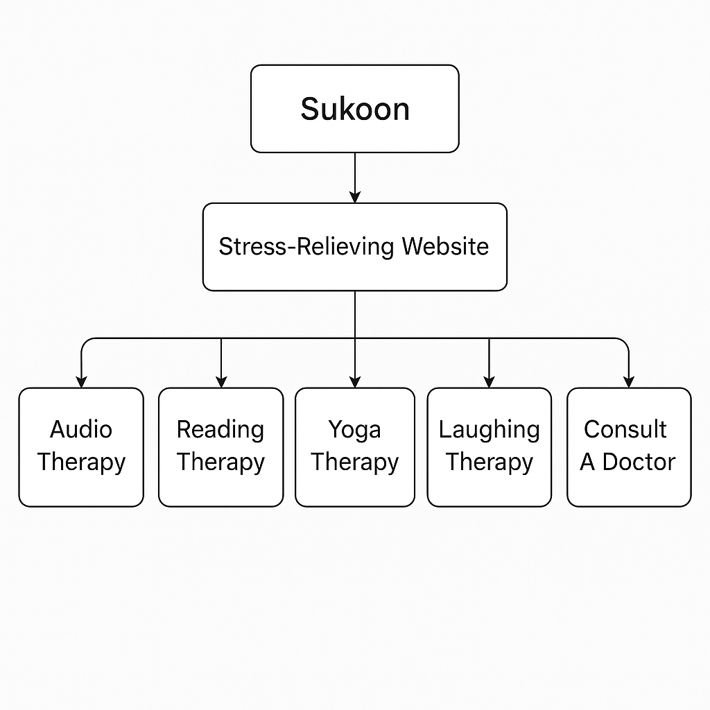

Output

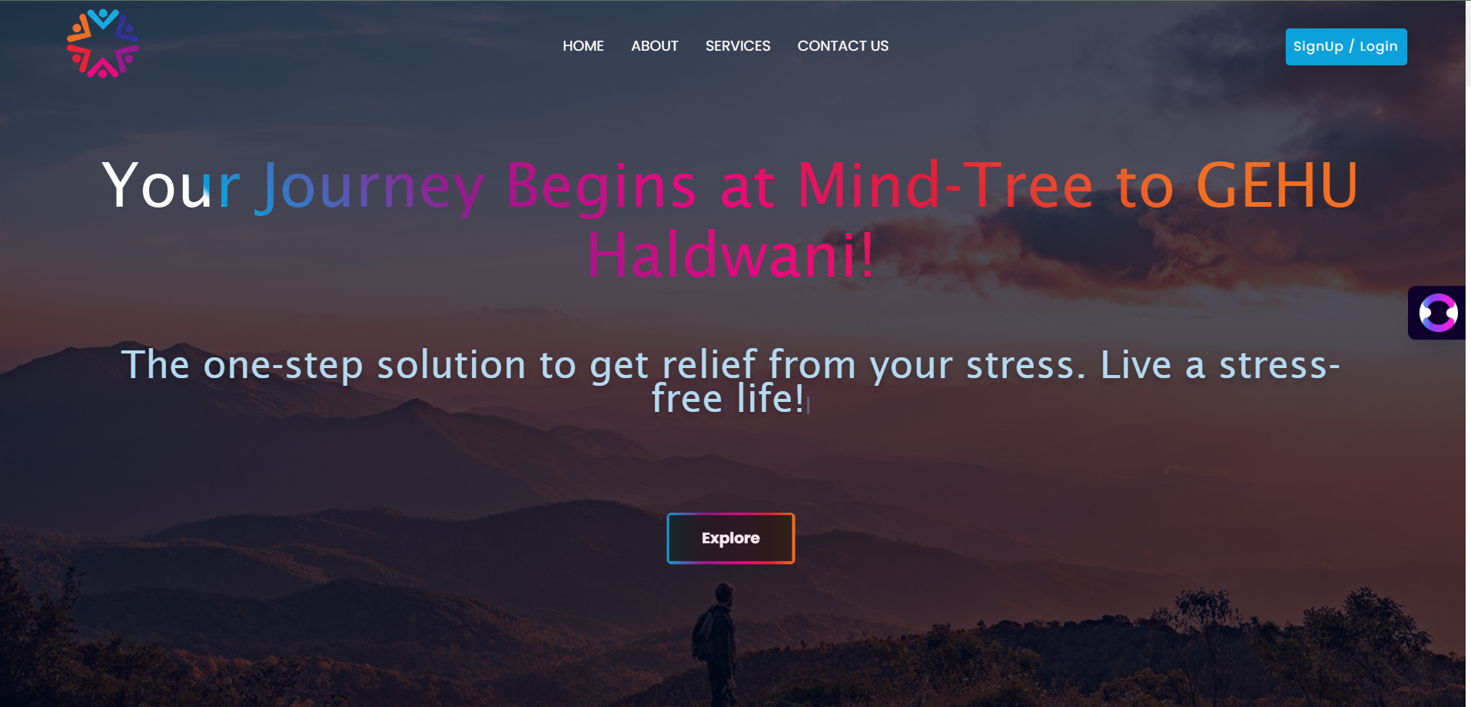

# CHAPTER 6

# Conclusion

# Sukoon stands as a meaningful contribution toward addressing mental health challenges in today's fast-paced world. Through a user-centric design and a holistic approach, the platform offers diverse stress-relief therapies, ranging from audio and reading materials to yoga and professional consultations. Developed during our first hackathon experience at Hackofiesta, this project not only enhanced our technical and collaborative skills but also allowed us to apply technology for social good.

# By bringing together relaxation tools, educational resources, and wellness guidance under one digital roof, Sukoon serves as a simple yet impactful step toward helping individuals prioritize their mental well-being. With future enhancements and community involvement, the platform has the potential to evolve into a powerful open-source wellness ecosystem.

# Bibliography

Book and references

Image Processing by Canva & Google

[www.google.com](http://www.google.com)

[www.Wikipedia.com](http://www.Wikipedia.com)

[www.Youtube.com](http://www.Youtube.com)